**Unit 1.5 - Worksheet 4**

**Working with Images in Pyret**

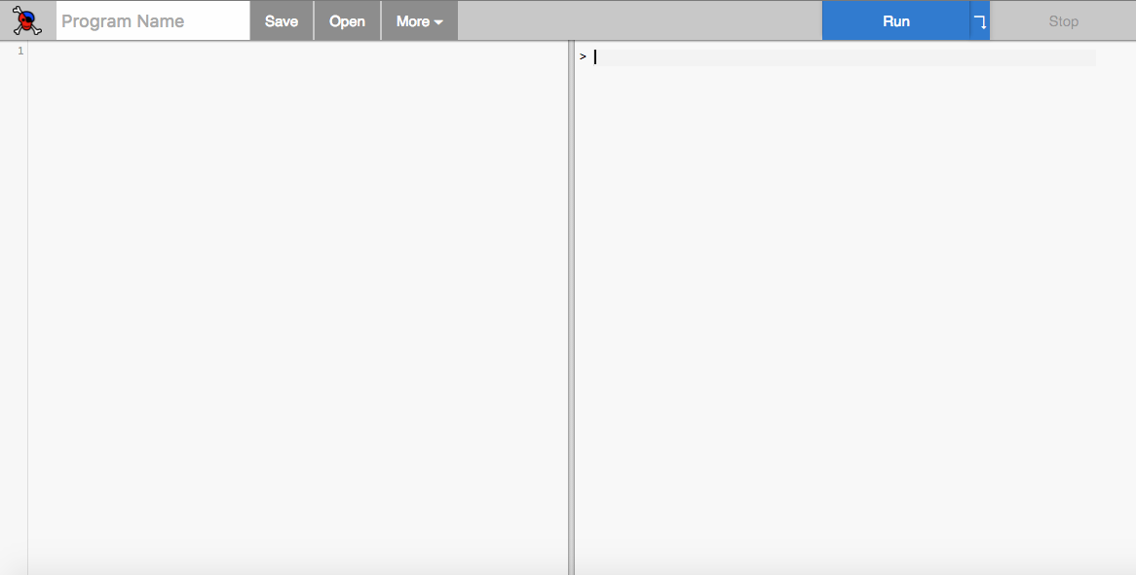

Definition

Side

Interaction Side

# **Image Functions in Pyret**

**Working with Library Functions**

*Predict* what would happen if you type circle(30, “solid”, “red”) into the right (interaction) window. Justify your prediction.

Type circle(30, “solid”, “red”) into the right (interaction) window and press *“enter”*. Was your prediction correct? If you did not get the output you predicted, why do you think this happen?

When working with image functions from the Pyret libraries, we need to ask Pyret to include these files into the programs we are writing.

Type the command **include** imageinto the interaction window. Note that Pyret auto-highlighted the word “include” in boldface. What do you think it means?

Now type circle(30, “solid”, “red”)into the right (interaction) window and press *return*. Describe the result.

Test *at least 3* image functions in the interaction windows and describe the results (provide both code and description of results).

**include** image

blue-circle = circle(50, "solid", "blue")

white-circle = circle(30, "solid", "white")

red-circle = circle(10, "solid", "red")

overlay(white-circle, blue-circle)

overlay(red-circle, white-circle)

overlay(red-circle,

overlay(white-circle, blue-circle))

overlay-align("middle", "bottom", red-circle, white-circle)

overlay-align("middle", "bottom", red-circle,

overlay-align("middle", "bottom", white-circle, blue-circle))

Now, try to play and create different pictures with other shapes… combine other shapes.

Share with your neighbor.